Supplementary Materials
Circular Economy Barriers and Drivers in the Construction Industry

This file contains supplementary tables and figures supporting the main manuscript. Table captions appear above tables; figure captions appear below figures.

Supplementary Table

Table S1. Measurement model assessment statistics
Construct | Items (n) | Loading range | Cronbach's α | CR | AVE | √AVE
Technical barrier | 12 | 0.649 – 0.780 | 0.917 | 0.930 | 0.525 | 0.724
Social barrier | 6 | 0.664 – 0.805 | 0.841 | 0.883 | 0.559 | 0.747
Financial barrier | 5 | 0.656 – 0.858 | 0.820 | 0.875 | 0.586 | 0.765
Awareness barrier | 5 | 0.694 – 0.828 | 0.850 | 0.893 | 0.626 | 0.791
CE Drivers (HOC) | 23 | 0.65 – 0.82 | 0.961 | 0.964 | 0.539 | 0.734
Note: CR = composite reliability. AVE = average variance extracted. HOC = higher-order construct. √AVE = square root of AVE, used in Fornell-Larcker discriminant validity criterion (Figure 5(a) in main manuscript). Items B1, B2, B15, D1, D7, D13, D18, and D21 were removed during iterative purification.

Supplementary Figures: PLS-SEM Additional Diagnostics

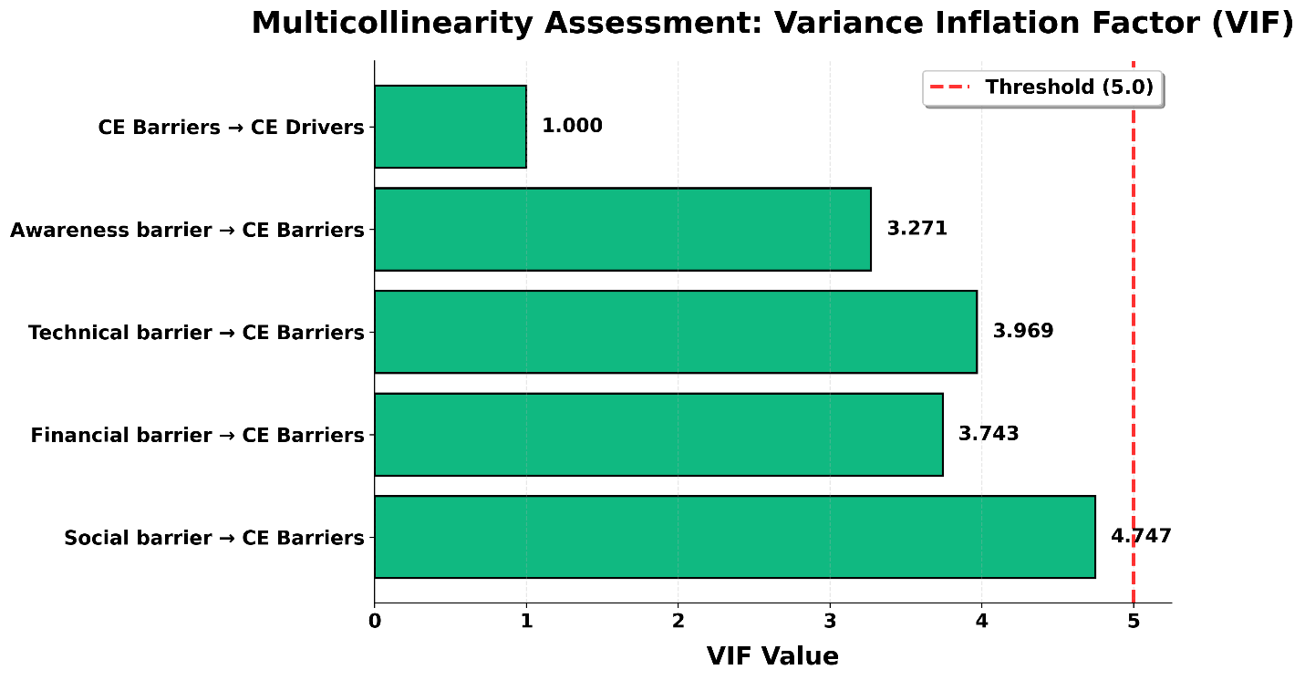
Supplementary Figure S1. Multicollinearity assessment: Variance Inflation Factor (VIF)
Note: All VIF values below the threshold of 5.0 (red dashed line). Social barrier (4.747) shows the highest VIF among first-order constructs. CE Barriers to CE Drivers VIF = 1.000.

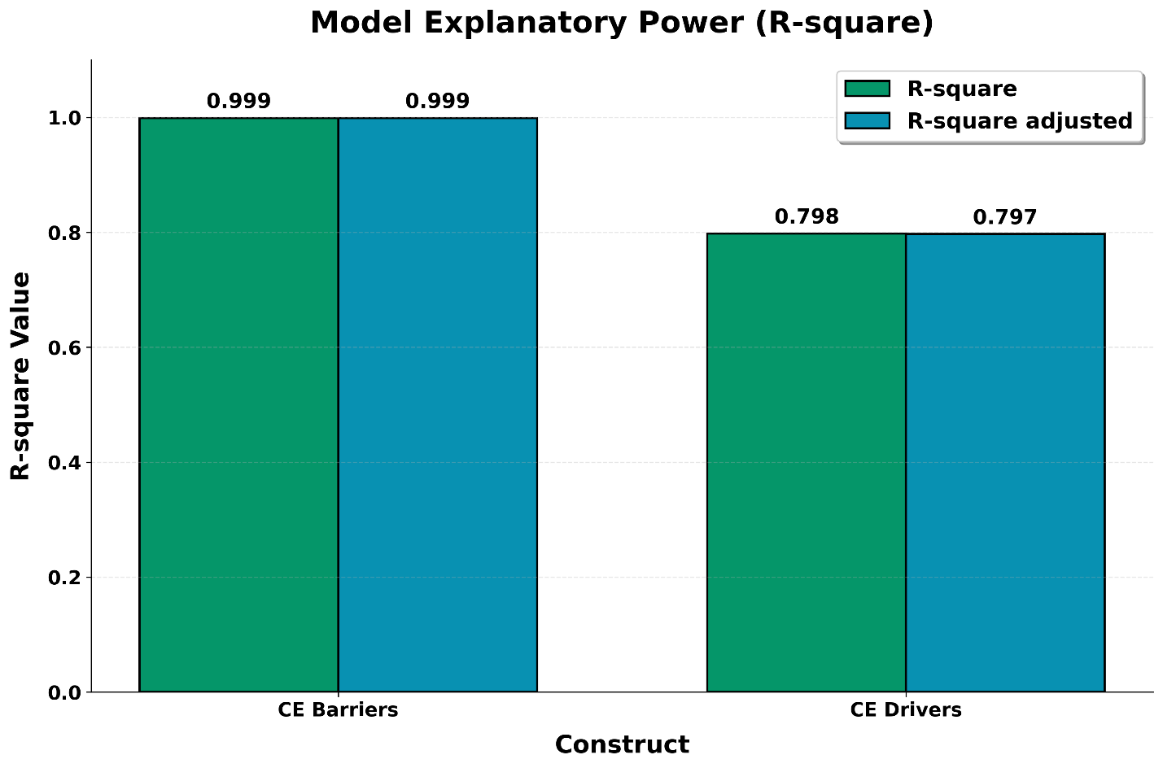
Supplementary Figure S2. Model explanatory power: R-square values
Note: R² CE Barriers = 0.999 (R²adj = 0.999); R² CE Drivers = 0.798 (R²adj = 0.797). The near-unity R² for CE Barriers reflects the tight reflective-reflective higher-order construct specification.

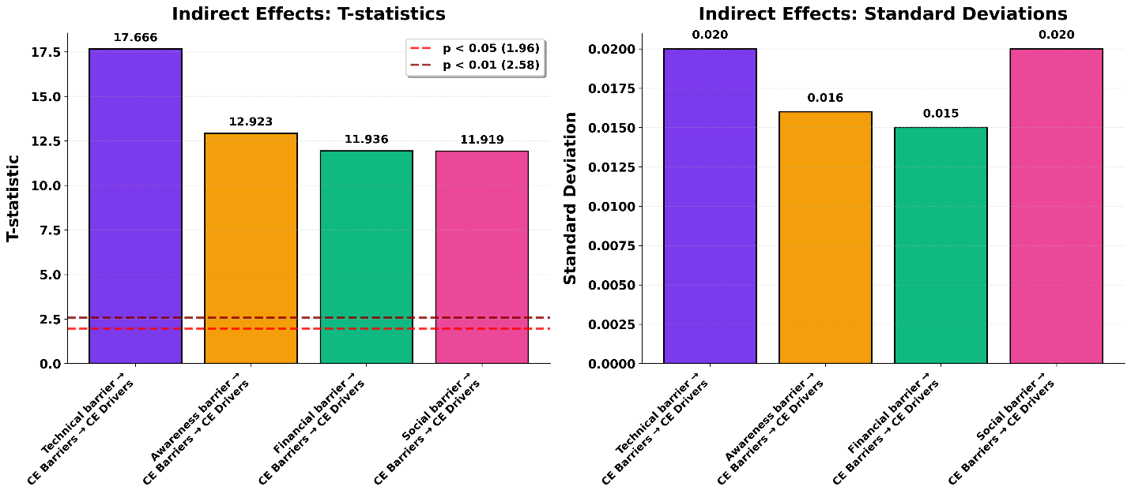
Supplementary Figure S3. Indirect effects: T-statistics and standard deviations
Note: Left panel = bootstrapped T-statistics for indirect effects of each barrier type on CE Drivers via CE Barriers HOC. Right panel = bootstrap standard deviations. All indirect effects are highly significant (T > 11.9, p < 0.001). Dashed reference lines: p < 0.05 (T = 1.96) and p < 0.01 (T = 2.58). Bootstrap subsamples = 5,000.

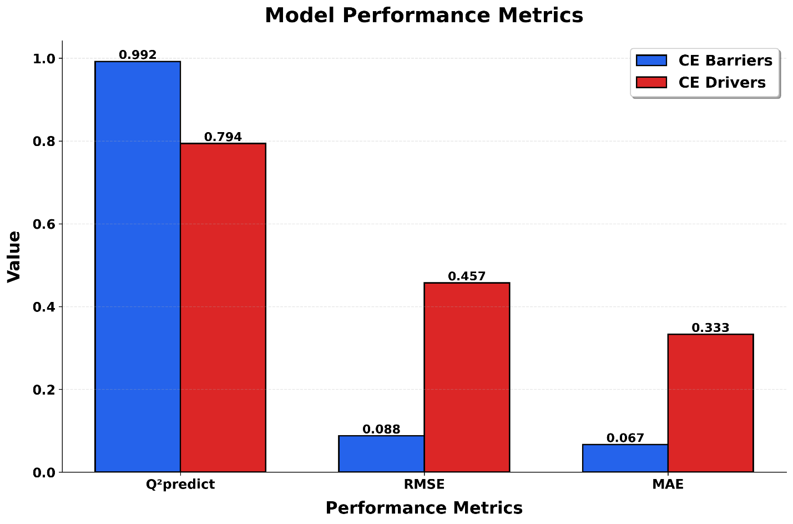
Supplementary Figure S4. Predictive relevance: Q²predict metrics
Note: Q²predict values > 0 indicate predictive relevance. CE Barriers Q²predict = 0.992; CE Drivers Q²predict = 0.794. Both values substantially above the zero threshold, confirming strong out-of-sample predictive relevance.

Supplementary Figures: Machine Learning Additional Results

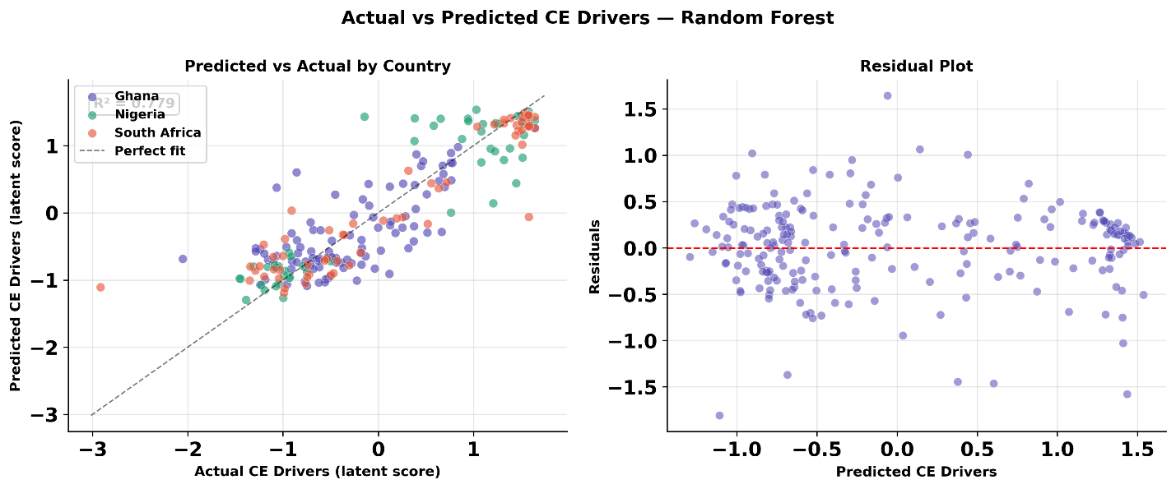
Supplementary Figure S5. Actual vs. predicted CE Drivers — Random Forest (best-performing model)
Note: Left panel = predicted vs. actual CE Drivers latent scores by country. Right panel = residual plot. Points closely follow the perfect-fit diagonal; residuals are distributed approximately evenly around zero. Purple = Ghana; green = Nigeria; orange = South Africa. R² = 0.779 (5-fold CV).

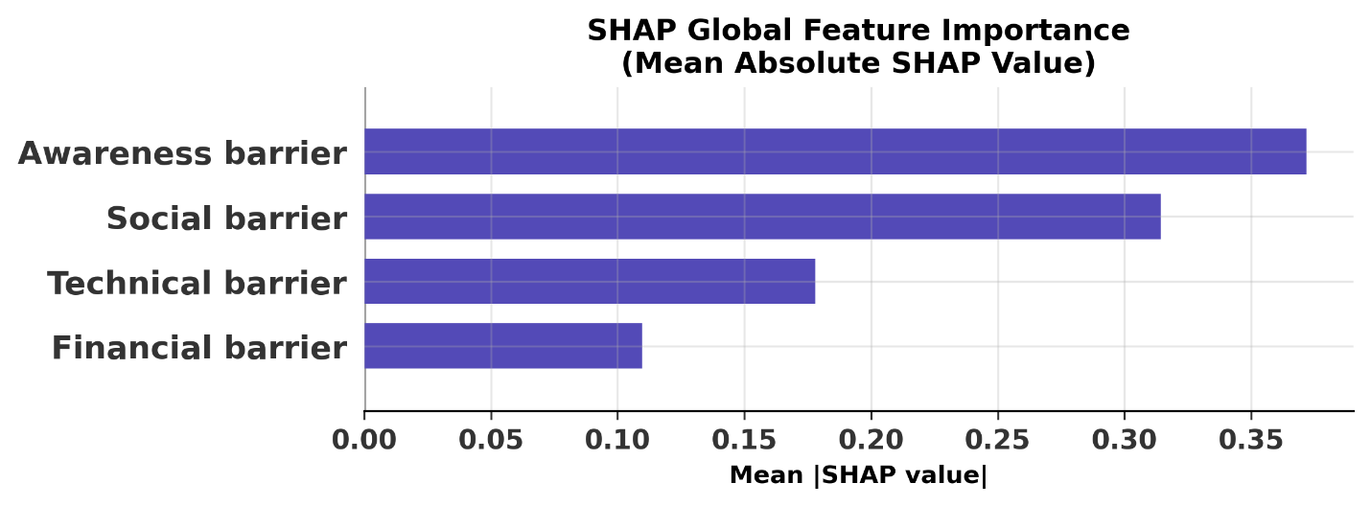
Supplementary Figure S6. SHAP global feature importance (mean absolute SHAP value)
Note: Mean absolute SHAP values from XGBoost TreeExplainer on full dataset (n = 218). Global ranking: Awareness barrier (0.370) > Social barrier (0.310) > Technical barrier (0.180) > Financial barrier (0.110). This global SHAP ranking diverges from the PLS-SEM path coefficient ranking; see Section 4.1 of the main manuscript for discussion.

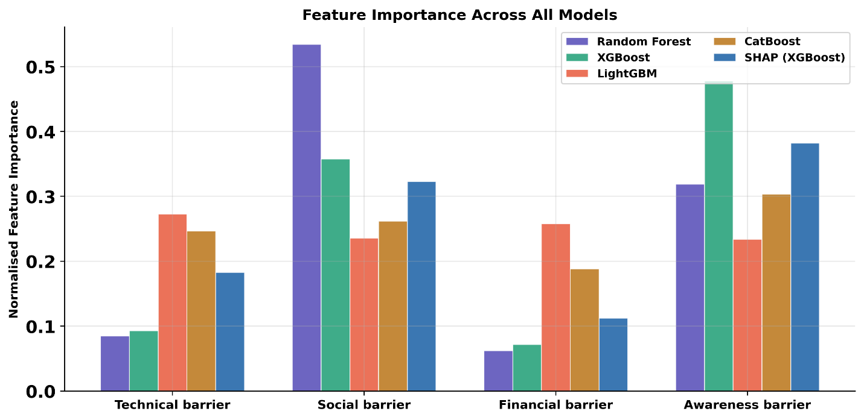
Supplementary Figure S7. Normalised feature importance across all five tree-based ML models
Note: All model importance values normalised to sum to 1.0 for direct comparison. SHAP (XGBoost) included as a fifth benchmark series. Social and Awareness barriers consistently rank among the top two features. Note that Random Forest and XGBoost assign higher relative importance to Social barrier, while LightGBM and CatBoost show a more balanced distribution.

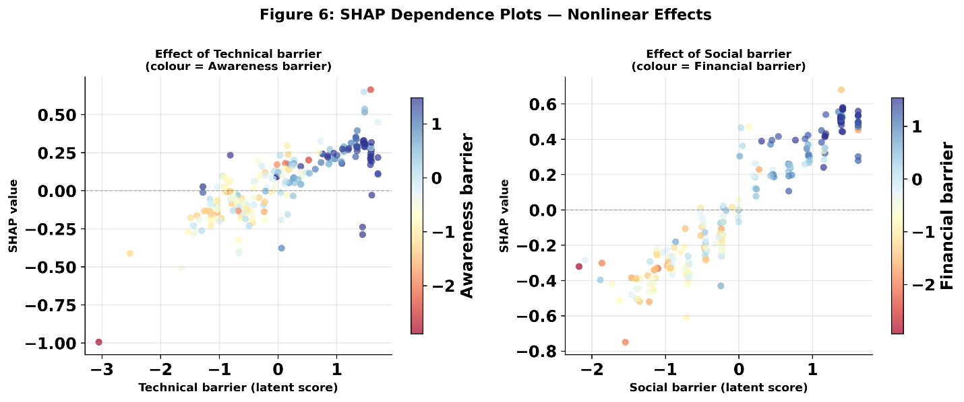
Supplementary Figure S8. SHAP dependence plots — nonlinear effects of Technical and Social barriers
Note: Left panel = Technical barrier effect (colour = Awareness barrier level). Right panel = Social barrier effect (colour = Financial barrier level). Both plots reveal approximately linear main effects with nonlinear patterns at extreme values. When Awareness barrier is high (blue), the positive effect of Technical barrier on CE Drivers is amplified. When Financial barrier is high (blue), Social barrier's positive effect is stronger.

Supplementary Figure: fsQCA Calibration

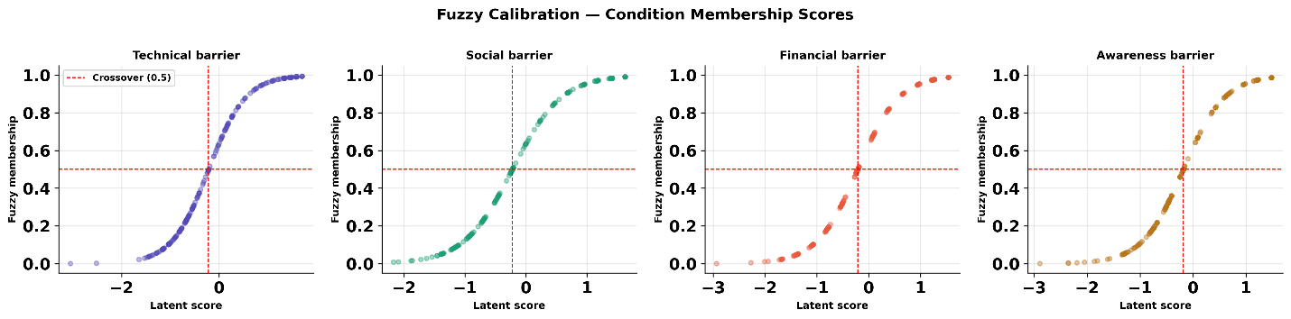
Supplementary Figure S9. fsQCA fuzzy calibration curves for all four CE barrier conditions
Note: Each panel shows the logistic calibration transformation from raw latent scores to fuzzy membership (0–1). Red dashed lines mark the crossover point at membership = 0.50 and corresponding latent score median. All four curves exhibit the expected S-shaped logistic pattern, confirming appropriate calibration. Percentile-based anchors: 75th percentile = fully in (0.95); median = crossover (0.50); 25th percentile = fully out (0.05).
Table S1: CE Barriers: indicators, descriptions, and sources
Category | Code | Description | References
Technical barrier
 | B1 | Lack of mature and complete municipal regulation system to guide CDW | (Bello et al., 2025; Durdyev et al., 2025)
 | B2 | Lack of regulations and implementation guidelines | (Akinade et al., 2020)
 | B3 | Insufficient technical resources and infrastructure (e.g., collection centres and recycling plants) for CE in construction | (Pittri et al., 2025; Sofolahan et al., 2024)
 | B4 | Lack of green designing of construction projects | (Akinade et al., 2020; Kanters, 2020)
 | B5 | Lacking standardisation/classification/certification/traceability/quality assurance | (Durdyev et al., 2025; Ofori et al., 2025)
 | B6 | Lack of CE metrics/tools/design | (Islam et al., 2025; Pittri et al., 2025)
 | B7 | Scaling difficulty for CE in construction | (Bello et al., 2025; Durdyev et al., 2025)
 | B8 | Unavailability of environmental management programs and facilities | (Ofori et al., 2023; Sofolahan et al., 2024)
 | B9 | Immature recycling technology | (Akinade et al., 2020; Durdyev et al., 2025)
 | B10 | Poor skills of operatives related to construction waste reduction and treatment | (Bello et al., 2025; Islam et al., 2025)
 | B11 | Lack of equilibrium in recycling and reuse market | (Alotaibi et al., 2024; Durdyev et al., 2025)
 | B12 | Lack of producer-based responsibility system in production | (Durdyev et al., 2025; Vollmers and Long, 2025)
 | B13 | Inadequate CE infrastructure to support CE management | (Abdulai et al., 2026; Sofolahan et al., 2024)
 | B14 | Insufficient application of the 3R approach by construction | (Asiedu et al., 2025; Sofolahan et al., 2024)
Social barrier
 | B15 | Cultural beliefs | (Durdyev et al., 2025; Vollmers and Long, 2025)
 | B16 | Prohibitive domestic policy | (Bello et al., 2025; Sofolahan et al., 2024)
 | B17 | Unrealistic hypothesis/social flexibility | (Durdyev et al., 2025; Islam et al., 2025)
 | B18 | Lack of green designing philosophy in construction projects | (Akinade et al., 2020; Kanters, 2020)
 | B19 | Strong belief that waste management is more expensive | (Asiedu et al., 2025; Kanters, 2020)
 | B20 | Perceived low status of individuals who use reclaimed and recycled materials | (Durdyev et al., 2025; Vollmers and Long, 2025)
 | B21 | Construction sector inertia | (Bello et al., 2025; Sofolahan et al., 2024)
Financial barrier
 | B22 | Conservative financial decision-making and lack of collaborative investment mechanisms for circular economy adoption | (Sofolahan et al., 2024; Vollmers and Long, 2025)
 | B23 | Additional construction cost for reclaimed and recycle materials | (Asiedu et al., 2025; Sofolahan et al., 2024)
 | B24 | Higher upfront cost | (Alotaibi et al., 2024; Bello et al., 2025)
 | B25 | High cost of establishing eco-industrial chains | (Asiedu et al., 2025; Durdyev et al., 2025)
 | B26 | Difficulty to break into the established markets dominated by industrial materials | (Bello et al., 2025; Sofolahan et al., 2024)
Awareness/knowledge barrier
 | B27 | Lack of demand in composite construction | (Alotaibi et al., 2024; Vollmers and Long, 2025)
 | B28 | Lack of interest in CE | (Abdulai et al., 2026; Ofori et al., 2025)
 | B29 | Limited knowledge in CE | (Abdulai et al., 2024; Bello et al., 2025)
 | B30 | Lack of adequate knowledge in building design | (Ofori et al., 2025; Sofolahan et al., 2024)
 | B31 | Lack of global vision | (Asiedu et al., 2025; Durdyev et al., 2025)

Table S2: CE Drivers: indicators, descriptions, and sources

Category | Code | Description | References
Legislation and Policy Support
 | D1 | Circular economy legislation | (Ajisomo et al., 2025; Rokio et al., 2024)
 | D2 | Laws and regulations prohibiting informal waste handling sector | (Onyia et al., 2025; Vollmers and Long, 2025)
 | D3 | Global agreement on regulations | (Kanters, 2020; Rokio et al., 2024)
 | D4 | Policy support | (Rokio et al., 2024)
 | D5 | Policy, education, and awareness | (Bello et al., 2025; Rokio et al., 2024)
 | D6 | Robust sustainability strategy to integrate circularity into long-term business goals and growth | (Abdulai et al., 2024; Vollmers and Long, 2025)
Economic Incentives and Market Development
 | D7 | Financial incentives | (Abdulai et al., 2024; Ding et al., 2025)
 | D8 | Green financial innovation | (Ding et al., 2025; Kanters, 2020)
 | D9 | Financing and market creation | (Abdulai et al., 2024; Rokio et al., 2024)
 | D10 | Development of secondary material markets | (Abdulai et al., 2024; Vollmers and Long, 2025)
 | D11 | Market maturity and material flow balance | (Kanters, 2020; Rokio et al., 2024)
 | D12 | Circular public procurement | (Kanters, 2020; Vollmers and Long, 2025))
Technological Advancements and Innovation
 | D13 | Development of enabling technologies | (Pittri et al., 2025; Soomro et al., 2026)
 | D14 | BIM (Building Information Modelling)-based design and evaluation | (Akinade et al., 2020; Pittri et al., 2025)
 | D15 | IoT (Internet of Things)-based material tracking | (Pittri et al., 2025; Soomro et al., 2026)
 | D16 | The use of sequential disassembly for deconstruction | (Akinade et al., 2020; Kanters, 2020)
 | D17 | Adequate technological infrastructure and equipment | (Pittri et al., 2025; Sofolahan et al., 2024)
Corporate and Social Engagement
 | D18 | Management commitment | (Rokio et al., 2024; Vollmers and Long, 2025)
 | D19 | Formation of green teams | (Abdulai et al., 2024; Vollmers and Long, 2025)
 | D20 | Strong corporate social responsibility targets and ethical standards | (Kanters, 2020; Rokio et al., 2024)
 | D21 | High priority on circularity within the organisation | (Abdulai et al., 2024; Vollmers and Long, 2025)
 | D22 | Collaboration between stakeholders | (Asiedu et al., 2025; Rokio et al., 2024)
 | D23 | A collaborative culture within the supply chain network | (Durdyev et al., 2025; Vollmers and Long, 2025)
 | D24 | Awareness-raising events and projects | (Bello et al., 2025; Ofori et al., 2025)
 | D25 | Commitment of private sector stakeholders | (Abdulai et al., 2024; Rokio et al., 2024)
 | D26 | Cradle to cradle paradigm | (Akinade et al., 2020; Kanters, 2020)
 | D27 | Environmental protection and leadership | (Rokio et al., 2024; Vollmers and Long, 2025)
 | D28 | Presence of better information exchange | (Abdulai et al., 2024; Soomro et al., 2026)

